CITY OF UMHLATHUZE
BY-LAWS RELATING TO THE BUILDING CONTROL MATTERS IN THE MUNICIPAL AREA
To provide a regulatory framework for the construction of buildings in formal areas and traditional settlement areas within the City of uMhlathuze municipal jurisdiction, to promote uniformity with formal areas and traditional settlement areas in terms of building structures that are sustainable, structurally sound and comply with the energy efficiency requirements, to bridge a gap between the stringent National Building Regulations and Standards Act, 1977 (Act No. 103 of 1977) and the unregulated traditional settlement areas, to establish a building standard and regulate the installation of structures, to provide guidelines for property owners regarding problem buildings within the City of uMhlathuze and the regulation thereof, to regulate structures that are referred to as minor building works in the National Building Regulation and Building Standards Act, 1977 (Act No. 103 of 1977); to enforce the building standard related thereto and provide for offences and penalties, and also provide appeal mechanism.

PREAMBLE
WHEREAS Section 24 of the Constitution of the Republic of South Africa (Act No. 108 of 1996) states that everyone has the right to an environment that is not harmful to their health or well-being; and to have that environment protected, for the benefit of present and future generations;
WHEREAS Section 32 of the Constitution states that everyone has the right to any information held by the state; and any information that is held by another person and that is required for the exercise or protection of any rights;
WHEREAS Section 156(1) of the Constitution confers on municipalities the right to administer local government matters listed in Part B of the schedule 4 and 5;
WHEREAS Section156(2) and (5) of the Constitution provides that a municipality may establish and administer Bylaws for the effective administration of the matters which it has a right to administer and exercise any power concerning a matter reasonably necessary for, incidental to, the effective performance of its functions;
WHEREAS Section 11(3)(m) of the Municipal Systems Act, 2000 (Act No. 32 of 2000) grants municipalities the right to adopt Bylaws;
WHEREAS Section 4 of the National Building Regulations and Standards Act, 1977 (Act No. 103 of 1977) empowers the Council to provide approval for applications in respect of erection of buildings;
WHEREAS Section 7 of the National Building Regulations and Standards Act, 1977 (Act No. 103 of 1977) empowers the Council to control the design and the construction of the buildings;
WHEREAS the Construction Regulations of 2014 under Section 43 of the Occupational Health and Safety Act, 1993 (Act No. 85 of 1993) describe the requirements and obligations that must be complied with when embarking on construction work to ensure that all construction work is performed in a safe manner.

CHAPTER 1
DEFINITIONS, APPLICATION OF THE BY-LAW, PRINCIPLES, NORMS AND STANDARDS AND POLICIES

1. Definitions
2. Application of By-law
3. Principles, norms and standards and policies

CHAPTER 2
BUILDING CONTROL BYLAW

4. Purpose of the Building Control Bylaw
5. Contents of Building Control Bylaw
6. Legal effect of Building Control Bylaw

CHAPTER 3
APPROVAL AUTHORITY
Establishment, Functions and Powers of the Building Control

7. Building Control Officer
8. Building Control Building and Drainage Inspector
9. Building Control Plan Examiner
10. Building Control Admin Clerk

CHAPTER 4
KEEPING OF RECORDS AND ACCESS TO INFORMATION

11. Record of the building control bylaw
12. Record of applications for building plan approval
13. Access to information held by Municipal Manager
14. Lodging of public complaint

CHAPTER 5
APPLICATIONS FOR BUILDING CONTROL APPROVAL
Categorisation of Building Plan Approval Applications

15. Erection of structures which require building plan approval
16. Signage (Outdoor advertisement)
17. Erection of structures which do not require building plan approval
18. Minor Building Works
19. Temporary Structures
20. Problem Buildings
21. Restriction on erection buildings:
21.1. Building activities that require approval from the municipality
21.2. Building inspection requirements
21.3. Certificate of occupancy
21.4. Demolition requirements
21.5. Disposal of building material
21.6. Relay of storm-water from high-lying erven to lower-lying erven
21.7. Sewer layout under covered and/or enclosed areas
22. Expiry period of an approved building plan
23. Boundary walls
24. Electric Fences
CHAPTER 6
TRADITIONAL SETTLEMENT AREAS:
Procedures relating to the management and control of structures erected within Traditional Settlement Areas
25. Building plan requirements
26. Site requirements
27. Structural requirements
28. Traditional burial graves & historic burial graves
29. Septic tank
30. Public safety
CHAPTER 7
ENFORCEMENT

Part 1: Appointment, Functions and Powers of the Municipal Building Control Law Enforcement Officer

31. Appointment of the Municipal Building Control Law Enforcement Officer
32. Powers and Functions of a Municipal Building Control Law Enforcement Officer

Part 2: Offences, penalties, reduction and disconnection of services

33. Offences and penalties
34. Additional penalties
35. Contravention penalty charge to prevent the continuation of an activity that constitutes an offence

Part 3: Prosecution

36. Entry by Building Control Law Enforcement Officer
37. Observance of confidentiality pertaining to entry for enforcement purposes
38. Relationship between remedies provided in this By-law and other statutory and common law remedies

CHAPTER 8
APPEALS

39. Appeals

CHAPTER 9
GENERAL PROVISIONS

40. Legal indemnification
41. Calculation of number of days
42. Short title and commencement
CHAPTER 10
SCHEDULE OF ANNEXURES

ANNEXURE A
FINE SCHEDULE: Offences and Penalties in relation to National Building Regulations Act 103 of 1977 and SANS 10400; Regulations made thereunder Section 19.1 Building Control Bylaw

ANNEXURE B
FINE SCHEDULE: Offences and Penalties in relation to City of uMhlathuze Building Control Bylaw;

ANNEXURE C
Written Notice to Appear in Court (Section 56 Criminal Procedure Act 51 of 1977)

ANNEXURE D
City of uMhlathuze Building Control Notice of Contravention

ANNEXURE E
Building Control Public Complaints form
ANNEXURE F
Minor building works application form

ANNEXURE G
Application for the erection of a temporary structure
ANNEXURE H
Application for demolition

CHAPTER 1
1. Definitions
In this Bylaw all words and phrases, except the words and phrases defined in this Bylaw, have the same meaning as in the National Building Regulations and Standards Act, 1977 (Act No. 103 of 1977), the National Building Regulations (NBR) made under the Act and the user’s code of practice for the application of the NBR, namely SANS10400 and, unless the context otherwise indicates –
“Accounting officer” means the Municipal Manager (MM) appointed by the council in the terms of Section 56 of the Municipal Systems Act.
“Advertising sign” means any physical structure built to display advertising
“Applicant” means any person who makes an application.
“Application” means an application contemplated in section 4 of the NBR.
“Approval” means formal approval made by the City of uMhlathuze or any authorised official contemplated in Section 7(7)(b) of the NBR.
“Approved” means approved by the City of uMhlathuze.
“As Built” means a structure that was approved for construction by means of an approved building plan but has deviated from the approved building plan.
“Authorised official” means an employee of the City of uMhlathuze such as Building Control Officer, Building Inspectors, Plan Examiners and Clerks, authorized by the Municipal Manager to implement and enforce the provisions of this Bylaw.
“Block” means any masonry unit which has a length more than 300mm or a width of more than 130mm.
“Boundary wall” is a wall constructed on the cadastral boundary as per the surveyor general diagram between one or two owners.
“Brick” means any masonry unit which has a length of 220mm or a width of 110mm.
“Building” includes-
- any structure, whether of a temporary or permanent nature irrespective of the materials used in the erection thereof, erected or used for or in connection with-
- the accommodation or convenience of human beings or animals;
- the manufacture, processing, storage, display or sale of any goods;
- the rendering of any services;
- the destruction or treatment of refuse or waste materials;
- the cultivation or growing of plant or crop;
- any wall, swimming bath, swimming pool, reservoir or bridge or any other structure connected therewith;
- any fuel pump or any tank used in connection therewith;
- any part of the building, including a building as defined in paragraph (a),(b) or (c);
- any facilities or system, or part or portion thereof, within or outside but incidental to a building, for the provision of water supply, drainage, sewer, and storm-water disposal, electricity supply or other similar services in respect of the building.
“Building control officer” means any person appointed or deemed to be appointed as a building control officer by the City of uMhlathuze in terms of section 5 of the NBR Act, (Act 103 of 1977).
“Building waste” means waste produced through the construction, alteration, repair or demolition of any structure both manmade and natural and includes rubble, earth, wood, rock, glass, plastic, metals, asphalt, bitumen and bitumen products, installation material, concrete, bricks, tiles, ceramics and gypsum based materials but exclude garden waste and asbestos.
“Canopy” means a structure in the nature of a roof projecting from the façade of a building and cantilevered from that building or anchored otherwise by columns or posts.
“Carport” means a building intended to provide a shelter for a motor vehicle, caravan or boat and having a roof but having walls on not more than two sides.
“Category 1 building” means building which,
- is designated as being of Class A3, A4, F2, G1, H2, H3, H4, Regulation A20 annexure A of the National Building Regulation
- has no basement
- has a maximum length of 6m between intersecting walls or members providing lateral support, and
- has a floor area that does not exceed 80m²
- roof should have no hips and valleys
“Cleaning eye” means access opening to the interior of a discharge pipe or trap provided for the purpose of internal cleaning, and which remains permanently accessible after completion of the drainage installation.
“Competent person” means a person who is qualified by virtue of his education, training, experience and contextual knowledge to make a determination regarding the performance of a building or part thereof.
“Conservancy tank” means a covered tank used for the reception and temporary retention of sewage, and which requires emptying at intervals.
“Discharge pipe” means pipe which conveys the discharge from a sanitary fixture to a drain, and includes a soil pipe, a waste pipe, a discharge stack, a branch discharge pipe or a fixture discharge pipe
“Earthed” means connected to the general mass of earth in such a manner as to ensure at all times and immediate safe discharge of electrical energy
“Encroachment” means any projection from a building which encroaches under, into or over any street or public place, building line, boundary line and municipal servitude.
“Electric fence” means an electrified barrier erected on top of the boundary wall or attached to a boundary wall or fence. It may consist of one or more conductors erected against trespass of persons or animals.
“Flood lines” means lines on a map or drawing depicting water levels likely to be reached by a flood having a specified recurrence interval.
“French drain” means trench filled with suitable material which is used for the disposal of liquid effluent from a septic tank or waste water
“Foundation” means that part of the building which is in direct contact with and is intended to transmit loads to the ground.
“Free-standing wall” means a wall, not being a retaining wall, without lateral support.
“Industrial effluent” means a liquid which might or might not contain matter in solution or suspension which is given off in the course of or as a result of any industrial, trade, manufacturing, mining or chemical process or any laboratory research.
“Inspection eye” means access opening to the interior of any pipe or pipe fitting in a drainage installation provided solely for the purposes of inspection and testing, and to which permanent access after completion of the drainage installation need not be provided.
“Masonry wall” means an assembly of masonry units joined together with mortar or grout.
“Owner” in relation to a building means-
- the person in whose name land is registered in the Deeds Registry KwaZulu-Natal
- the beneficial holder of a real right in land or a holder of a registered long term lease
- an Organ of State in whom land vests, or if it has been given notice of its intention to expropriate the land
- a person who is a beneficial occupier of land in accordance with customary law or practice or community rules adopted by community members in terms of the adopted constitution of land holding entity.

“Party boundary wall” means a wall that stands astride a boundary and the boundary will normally run along the centre line of the wall.
“Percolation rate & test” is the test to determine the water absorption rate of soil (that is, its capacity of percolation) in preparation for the building of the septic drain field (leach field) or infiltration drain.
“Prefabricated septic tank” means a single piece factory made unit, including inlet and outlet openings, which leaves the factory completed, controlled and ready for installation.
“Property” means any erf, erven, lot(s), plot(s) or stand(s), portion(s) or part(s) of farm portions or agricultural holdings, registered in the deeds registry as such.

“Problem building” includes any building or portion of a building-
a) that appears to have been abandoned by the owner with or without the consequence that rates or other service charges are not paid;
b) that is derelict in appearance, overcrowded or is showing signs of being unhealthy, unsanitary, unsightly or objectionable;
c) that is the reason of written complaints in respect of criminal activities, including drug dealings and prostitution;
d) that is illegally occupied;
e) where refuse material is accumulated, dumped, stored or deposited with the exception of licence waste disposal facilities; or
f) that is partially completed or structurally unstable and is a threat or danger to the safety of the general public.
“Septic tank” means a tank designed to receive sewage and to effect the adequate decomposition of the organic matter in the sewage.
“Sewer” means a pipe or conduit which is in the property which is used or intended to be used for the conveyance of sewage.
“Strata forming” in geology and related fields means is a layer of sedimentary rock or soil, or igneous rock that were formed at the earth’s surface, with internally consistent characteristics that distinguish it from other layers.
“Storage tank” means tank, other than any tank used for storage of hot water or any cistern serving a toilet pan or a urinal, which forms part of a water installation and is used for the storage of water.
“Storm-water” means water resulting from natural precipitation or accumulation and includes rainwater, surface water, subsoil water or spring water.
“Storm-water drain” means a pipe, conduit or surface channel situated on a site, which is used to convey storm-water to a suitable point of discharge.
“Temporary structure” means any structure that is declared by the owner and that is being used or is to be used for a specific purpose for a specified period of time, but doesn’t include a builder’s shed.
“Traditional settlement area & inclusive of agri-village” means the area which falls within the area of the City of uMhlathuze and which is occupied by traditional communities or people who own land communally through a land holding entity or people who occupy land without a formal layout plan.
“Ventilation pipe” means a vent pipe which leads to the open air at its highest point and which provides ventilation throughout a drainage installation for the purpose of preventing the destruction of water seals, but does not include discharge pipe.
“Vent stack” means a main vertical ventilation pipe of any part of a drainage installation.
“Waste water” means used water which is not contaminated by the soil water or industrial effluent and which does not include storm-water.
“Water seal” means water in a trap which acts as barrier against the flow of any foul air or gas.

2. Application of this Bylaw

(1) This Bylaw applies to all land which falls within the municipal area under City of uMhlathuze and binds all persons, the Municipality and organs of state, to the extent applicable.
(2) When considering an apparent conflict between this Bylaw and another law, a court of law must prefer any reasonable interpretation that avoids a conflict over any alternative interpretation that results in a conflict.
(3) In the event of a conflict between the Building Control Bylaw and the NBR, the provisions of this By-law shall prevail to the extent that the provisions of this By-law give effect to “municipal building control” as an exclusive executive local government competence as contemplated in Part B of Schedule 4 of the Constitution.
(4) No person may erect a structure or develop land without approved building plans or approval granted in terms of this By-law.

3. Principles, norms and standards and policies

(1) Any development principles and any norms and standards applicable to building control made in terms of national or provincial legislation apply to the Municipality.
(2) The Municipal Council may adopt policies, procedures and guidelines, which are consistent with national legislation, provincial legislation or this Bylaw to guide applications or decisions made in terms of this By-law.
(3) If the Municipal Council intends to adopt or amend a policy, procedure and/or guideline that may materially and adversely affect the rights of any individual or the public, the Municipality must follow a public participation process which is consistent with public consultation provisions of the Municipal Systems Act.

CHAPTER 2
BUILDING CONTROL BYLAW

4. Purpose of the Building Control Bylaw
This Bylaw is supplementary to the National Building Regulations and is applicable to every buildings and structures, sewerage installation, water installation and storm-water drainage installation, to the operation and maintenance of any such installation in any new building or existing building with or without any alteration or additional to such an existing installation, whether or not required by the Council to be made or altered in terms of the National Building Regulations and this Bylaw.
5. Contents of Building Control Bylaw
The building control bylaw must comply with the NBR and-
- define the structure to which it applies;
- define the terminology used in the plan and clauses; and
- specify types of structures that are permitted and the conditions under which they are permitted; and
- specify structures that are not permitted;
- specify the extent to which structure is being used lawfully for a purpose that does not conform to the municipal bylaws may be continued to be used for that purpose and the extent to which buildings or structures on that land may be altered or extended.

6. Legal effect of Building Control Bylaw
(1) An adopted building control Bylaw-
- has the force of law and all land owners and users of land, including a Municipality and organ of state, within the municipal area are bound by the provisions of such a Bylaw;
- is an extension of the NBR within the municipal area to which it applies; and
(2) Structures may be erected only in the manner and for the purposes laid out in the approved building plans.

CHAPTER 3
MUNICIPAL BUILDING CONTROL APPROVAL AUTHORITY INSTITUTIONS
Establishment, Functions and Powers of the Building Control

7. Building Control Officer (BCO)
The Municipality must appoint a person as a Building Control Officer in order to exercise and perform the powers, duties or activities granted or assigned to a BCO by or under the NBR.

7.1. Functions and Powers of BCO
A Building Control Officer shall-
- make recommendations to the Municipality, regarding any plans, specifications, documents and information submitted to such local authority in accordance with Section 4 (3) of the NBR;
- ensure that any instruction given in terms of the NBR by the Municipality be carried out;
- inspect the erection of a building, and any activities or matters connected therewith, in respect of which approval referred to in Section 4 (1)of the NBR was granted;
- reports to the municipality, regarding non-compliance with any condition on which approval referred to in Section 4(1)of the NBR was granted.
- When a fire protection plan is required in terms of the NBR by the Municipality, the BCO concerned shall incorporate in his recommendations referred to in subsection (a) a report of the person designated as the chief fire manager by such local authority, or of any other person to whom such duty has been assigned by such chief fire manager, and if such building control.

8. Building Control- Building & Drainage Inspector
A Building Inspector performs skilled/specialized inspection and building plan review work involving the interpretation and enforcement of Building Codes, Regulations for both building, health and safety issues and performs related work as required.

8.1. Functions and powers of a Building & Drainage Inspector
A Building Inspector -
- Is the authorized official who may enter any premises at any reasonable time with a view to investigate, monitor, inspect and regulate as outlined in SANS 10400 and in this Bylaw.
- Respond to inquiries and complaints from the public regarding codes and other issues with projects, both over the phone, at the public counter and on site.
- Issue notices for non-compliance as contemplated in subsection (a) of this Bylaw and NBR.
- Attends to public complaints regarding building encroachments and illegal construction.
- Recommend for occupancy and the authority to revoke occupancy.

9. Building Control- Plan Examiner
A Plan Examiner is responsible for ensuring that the plans submitted to the municipality are in accordance with Regulation A2 (1) as stipulated in the NBR and Building Standards Act, 1977 (Act No.103 of 1977). The Plan Examiner reviews and assesses all plans and application documentation submitted for compliance with all local municipal bylaws and codes; and does related work as required.

9.1. Functions and powers of Plan Examiner
- Scrutinize building plans in detail for compliance with the NBR and Building Standards Act 1977, (Act No.103 of 1977), municipal Bylaws, SANS codes and all other legislation.
- Check building plans and compare manufacturer details and specifications, circulate plans for comments by other departments.
- Check all other related forms, fees for correctness and approves / reject the application.
- Reviews building plan applications and materials for all significant structures/developments.
- Liaise with homeowners, developer, builders, architectural professional and engineers in order to obtain compliance on plans submitted.
- In order to ensure that laid down specifications, standards and statutory requirements controlling prescriptions and approval of building plans are observed, building plans processed and notification of referrals/approval on submissions are circulated within established timeframes.
- Referrals/ Approval of plans are returned to the clerks for further processing
- Reports directly to the Building Control Officer

10. The Building Control Admin Clerk
Renders an administrative support function to the Building Control Section

10.1. Functions of Building Control Admin Clerk
- Provide administrative support to Building Control such as-
- managing the processing of building plan applications from submission time until the application has been approved or rejected;
- control record keeping for all application received;
- deals with inquiries/ complaints from public whether in person or telephonically and transfers calls to rightful intended;
- managing building plan archives and the movement of files thereof;
- compile building control statistics for STATS SA

CHAPTER 4
KEEPING OF RECORDS AND ACCESS TO INFORMATION

11. Record of the building control bylaw
The Building Control Bylaw must be reviewed annually, unless otherwise specified by the NBR and City of uMhlathuze.

12. Record of applications for building plan approval
12.1. The Municipality must keep the register of all building plan applications submitted for approval.
12.2. The Municipality must keep the copies of approved building plan and application documents to which the public has a right to access. The following is required from the public to access municipal records:
- presentation of Rates Statement
- Identity Document of owner
- Power of attorney/ Proxy letter with proof of identity of authorised individual

13. Access to information held by Municipal Manager
The records that are held by the Municipal Manager must be regarded as records that are automatically available as contemplated in Section 15 of the Promotion of Access to Information Act 2 of 2000.

14. Lodging of public complaint
14.1. Complainant to complete the Public Complaints form with all the relevant details and contact numbers.
14.2. Building Control Officer to allocate building Inspector to investigate allegation.
14.3. Findings to be recorded on the Action Form for public complaints.
14.4. Building Control Officer to make recommendations regarding the outcome.

CHAPTER 5
APPLICATIONS FOR BUILDING CONTROL APPROVAL: Categorisation of Building Plan Approval Applications

15. Erection of structures which require building plan approval
15.1. All structures as laid out in the NBR and in Section 13 listed below require building plan approval:
- carports;
- swimming pools, koi ponds and water feature exceeding 300mm depth;
- awnings;
- boundary walls or fences excluding diamond mesh;
- signage (outdoor advertisement);
- telecommunication towers;
- lightning arrestors&
- floodlights exceeding height of 3,0m;
- temporary structures;
- underground and aboveground fuel storage tanks;
- silos;
- wooden decks exceeding 900mm in height;
- change of roof design from gable to hip roof, from flat roof to gable or hip roof;
- any internal alteration;
- reservoirs and bridges.
- retractable awnings

16. Signage
General Provision
16.1. Outdoor advertisement exceeding 9m², that is mounted on the building or roof top, or mounted on a free standing post or column constructed on a foundation require an approval by the Municipality in respect of submission of building plan prior to installation.
17. Erection of structures which do not require building plan approval
17.1. Permeable roof structures are exempt from building plan approval. These structures include:
- shade cloth
- pergola

18. Minor Building Works
Any structural building work that is defined as a minor building work requires authorisation by the Municipality before the owner may commence with any work (refer to Annexure F for the application form for minor building works). These minor works are as follows:
- braai area without any roof covering;
- wooden gazebo not exceeding 15m²;
- garden/tool shed/wendy house not exceeding 10m², should be used only for storage purposes and; must be built in such a way that it is not visible from the public street and is 2m away from the adjacent boundary;
- child’s playhouse not exceeding 15m²;
- shrines or place of worship not exceeding 10m² provided it does not require any structural support;
- animal shelter not exceeding 10m²;
- replacement of windows or doors provided that the existing frames are not load bearing and that the openings are not enlarged, or that any openings needed for fire escapes are not removed;
- minor repairs to a house or shop- for example, replacement of the same or similar roofing or tile/ sheeting;
- new appliances or new fitting- for example, installing new toilet, bath or geyser or changing the position of these, provided that the work does not require new or extended drainage or plumbing.

19. Temporary Structures
No person should install a temporary structure without a written permission from the Municipality. 19.1. The applicant may apply to install the structure for the duration of 12 months.
19.2. If the applicant requires extension of time, the following is required:
- a formal submission of building plan and submission fee;
- must specify on the application the purpose and the use of the structure; and
- must specify the period she or he intending to have the structure.

19.3. Temporary structure should be built or installed without foundations and concrete floor slabs.
19.4. These structures must not encroach on boundary line, building line, road reserve and municipal services.

19.5. Removal of temporary structure
The property owner is responsible to demolish/ remove the temporary structure within 14 days of the expiry date of the approval granted.

20. Problem Buildings
20.1. Notice of intention to declare the building as a problem building
In the event that the Municipality is of the opinion that the building should be declared a problem building as defined in Chapter 1 of this Bylaw, it must serve a written notice to the owner:
- informing the owner that the Municipality intends to declare the building to be a problem building;
- giving reasons why the Municipality intends to declare the building to be a problem building;
- inviting the owner to make a written presentation, within 7days of the notice, on why the building should not be declared a problem building; and
- providing an address, email address to which representation may be submitted.

20.2. Declaration of a problem building
The Municipality must, after considering any representation received from the owner as referred to Section 20.1, either
- decide not to declare the building to be a problem building or;
- declare the building to be a problem building.

  - Compliance notice
    - The authorised official shall serve the notice on the owner, or occupant, or representative of the owner of any building which has been declared a problem building requiring such owner within a specified period to-
- repair, renovate, repaint, alter, close, demolish, secure, or remove all refuse from such problem building;
- complete the construction of a problem building or any structure of such building;
- enclose, fence or barricade such problem building to the satisfaction of the Municipality;
- appoint and instruct, at the cost of such owner, an approved competent person, referred to “A19” of the NBR, to examine a condition that gave rise to the declaration of such problem building and to report to the authorised official on the nature and extent of the steps to be taken, which in the opinion of such approved competent person needs to be taken in order to render such problem building safe;
- dispose of, destroy or remove any material or article accumulated, dumped, stored or deposited in any building, which is refuse or waste and which is showing signs of becoming unsightly, unsanitary, unhealthy or objectionable or is likely to constitute an obstruction; or
- comply with any provision of this Bylaw.

    - The municipality may, if such owner fails to comply with a notice served on him or her in terms of subsection 20.4.1, repair, renovate, repaint, alter, close, demolish, remove all refuse or secure any problem building and recover such costs from the owner.
    - The municipality may, if the owner fails to pay such cost including any fine which may be imposed on to the person concerned, recover the cost by charging it to the owner’s municipal account or institute court action.
  - Serving of a notice
20.4.1. Whenever a compliance notice is required to be served on a person in terms of this Bylaw, it is deemed to have been effectively and sufficiently served on such person-
- when it has been delivered to him or her personally;
- when it has been left at his or her place of residence or business in the Republic of South Africa with a person apparently over the age of 18 years;
- when it has been posted by the registered or certified mail to his or her last known residential or business address in the Republic of South Africa and an acknowledgement of the posting thereof is produced;
- if his or her address in the Republic of South Africa is unknown, when it has been served on his or her agent or representative in the Republic of South Africa in the manner contemplated in paragraphs (a),(b) or (c); or
- if his or her address and agent in the Republic of South Africa are unknown, when it has been affixed to conspicuous place on the building.

  - Control of problem buildings
20.5.1. Profiling problem buildings
The municipality must, as soon as possible after a building has been declared to be a problem building, undertake an investigation to identify-
- those aspects of the building which are in contravention of this Bylaw and any other legislation;
- any risk to the safety of the occupants of the problem building or public;
- profile the occupants to determine the following characteristics of the occupiers:
- the number of children;
- the number of women;
- the number of disabled persons;
- the number of elderly persons;
- the number of people residing per room and the area of each room occupied as a residence;
- the total number of people residing in the problem building.

20.5.2. The owner or the authorised agent of the problem building is entitled to be present while investigation is being undertaken and, if so present, must be given the opportunity to make representations during such investigation.

20.5.3. Where the representations have been made in terms of subsection 20.6.2 the authorised official must write down such representations and ensure that the owner or authorised agent is given the opportunity to sign such representation.

20.6. Ban on new occupants
20.6.1. The municipality may, once a problem building has been profiled, apply to the court for an interdict restricting the owner/ authorised agent-
- allowing any other people, in addition to those identified in the profile of occupants, from occupying or residing at the building
- filling any vacancy which may arise as a result of any person identified in the profile of occupants vacating the building.

  - Rehabilitation of problem buildings
    - Engagement with the owner
The municipality must, once a problem building has been profiled as contemplated in Section 20.5 serve a notice to the owner:
- identifying those aspects of the building which are in contravention of this Bylaw or any other applicable laws;
- identify any risks to the safety of the occupiers of the problem building and public;
- specify steps which the owner is obliged to take as stipulated in subsection 20.4.1(a)(b)(c)(d) and (e), within the time specified in the notice, in order to rectify those contraventions or remove those risks.
  - Eviction
Where the owner of a problem building fails to comply with a compliance notice, the municipality may after having complied with the engagement process with the occupants, apply to court to order for the eviction of the occupants.

21. Restriction on erection of buildings:
21.1. Building activities that require approval from the municipality
- No structures must without express permission of the Municipality be erected as contemplated in section 4(1) of NBR or this Bylaw.
- The municipality should be consulted before the deviation to approved plan occurs during the construction in order to determine whether it would be considered for approval when amendment plan is submitted.

21.1.1 Building activity that requires approval of the Municipality includes the following:
  - construction of new buildings whether residential, commercial and industrial; or
  - other structures such as tool sheds or wendy house exceeding 10m², builders sheds, temporary structures, containers, towers, solid fuel stores of any area, prefabricated buildings, open-sided carports or boatshed or caravan shelter of any area, poultry sheds or aviaries of any area, all boundary walls or fences excluding diamond mesh, driveways;
  - awnings or canopies exceeding 900mm horizontal projection;
  - private swimming pools, koi ponds or any other water feature exceeding depth of 0,3m;
  - extension to existing building whether residential, commercial and industrial
  - undertaking alteration to an existing building including structural alteration, alteration of internal walls, partitioning, changing the use of rooms within the building;
  - installing new or altering existing services, such as sewer, water, storm-water, electrical hydraulic works
  - demolition of building, engineering works or services, installing signage, communication mast and some fences

21.1.2. Requirements prior to construction
- Any proposed use or development on demarcation of the land within the City of uMhlathuze jurisdiction requires approval of the municipality in terms of submission of building plans. For the purpose of this requirement, the municipality reserves the authority to determine the position of building lines, municipal services such as water, sewer, electrical etc.
- Therefore the municipality is responsible for the following in accordance to the Building Control Bylaw-
    - responsible for the processing and approving of building plans of residential, commercial, industrial and including municipal/ state owned buildings or developments
    - inspect building construction from time to time and declare the building fit for the occupation upon its completion
    - control illegal building construction, prepare reports, issue notices and initiate legal action
    - issue temporary permits for temporary structures, placement of building materials
- Applications will not be accepted or assessed until all relevant plans, elevations and supporting documents are submitted and the appropriate application fee has been paid.
- All applications are subject to pre-scrutiny by Land Use Management and Aesthetics Committee before formal submission.

  - Building inspection requirements
- Early construction commencement shall not be granted by the Municipality until building plan application has been approved.
- The owner of any site intending to clear the site or commence the earthworks before the approval of his/ her building plan application may request in writing to the municipality for permission, stating the Erf of the particular site, street address and the date he or she intends to commence with the construction work.
- Where approval of building plan has been granted by the Municipality, it is the responsibility of the owner to notify Municipality in writing when commencing the construction of buildings or structures
- Compulsory inspection of buildings or structures is conducted as follows:
- excavation or trench inspection before casting concrete
- damp proof membrane inspection before casting the floor slab
- open inspection of sewer installation in accordance with approved building plan
- open roof inspection
- completion of the building work in accordance with the approved building plan
- When the building work has been carried out and completed to the satisfaction of the municipality, the owner must apply for a Certificate of Occupancy.
- Any owner or person who contravenes the requirements of this Bylaw shall be guilty of an offence.

  - Certificate of Occupancy
Before any building may be occupied a Certificate of Occupancy is required to be obtained from the Municipality. The certificate of occupancy may be issued by the Municipality when-
- building rubble material has been removed from site and disposed to a legal dumping site and the owner will be required to provide the Building Control Officer with proof of a weighbridge certificate indicating that the full mass of the building rubble has been disposed to a licenced waste disposal facility;
- excess building material is removed from the road reserve and stored within the property;
- property must have a house number/ street number/ Erf number installed and visible from the street;
- driveway is constructed from the road to the entrance of the property.

  - Demolition requirements
    - No owner or person is permitted to demolish any structure, whether it is the whole building or alteration of existing structure without prior written permission by the municipality.
    - The application to demolish should be submitted to the Municipality subject to 14 days’ notice of such intention thereof.
    - The owner or person must ensure that before any demolition work is carried out, and in order to ascertain the method of demolition to be used, a detailed structural engineering survey of the structure to be demolished is carried out by a competent person and that a method statement on the procedure to be followed in demolishing the structure is developed by that person.
    - During demolition, the competent person appointed by the owner of the building must check the structural integrity of the structure at intervals determined in the method statement contemplated in sub-regulation 21.5.3, in order to avoid any structural collapses.
    - The owner or person of such structure that is to be demolished must ensure that-
- no floor, roof or other part of the structure is overloaded with debris or material in a manner which would render it unsafe;
- all reasonably practicable precautions are taken to avoid the danger of the structure collapsing when any part of the framing of a framed or partly framed building is removed, or when reinforced concrete is cut; and
- precautions are taken in the form of adequate support or other means that may be necessary to prevent the accidental collapse of any part of the structure or adjoining structure;
- where the stability of an adjoining building, structure or road is likely to be affected by demolition work on a structure, steps are taken to ensure the stability of such structure or road and the safety of persons;
- ascertain as far as is reasonably practicable the location and nature of electricity, water, gas or other similar services which may in any way be affected by the work to be performed, and must ensure that before the commencement of demolition work that may affect any such service, take the steps that are necessary to render circumstances safe for all persons involved;
- every stairwell used and every floor where work is being performed in a building being demolished, to be adequately illuminated by either natural or artificial means;
- convenient and safe means of access to be provided to every part of the demolition site in which persons are required to work; and
- precautions are taken to erect a catch platform or net above an entrance or passageway or above a place where persons work or pass under, or fence off the danger area if work is being performed above such entrance, passageway, or place so as to ensure that all persons are protected where there is a danger or possibility of persons being struck by falling objects.
    - Where the demolition work involves the use of explosives, a method statement must be developed in accordance with the applicable explosives legislation, by an appointed person who is competent in the use of explosives for demolition work and all persons involved in the demolition works must adhere to demolition procedures issued by the appointed person.
    - Where there is presence of asbestos, the owner must ensure that all asbestos related work is conducted in accordance with the Asbestos Regulations, 2001, promulgated by Government Notice No. R. 155 of 10 February 2002.
    - Where there is presence of lead, the owner must ensure that all lead related work is conducted in accordance with the Lead Regulations, 2001, promulgated by Government Notice No. R.236 of 28 February 2002.
    - The owner of the site must make sure that all building waste and debris is removed and disposed of from site at a licenced waste disposal facility, providing the proof to the municipality of such facility.
  - Disposal of building rubble
When the building plans are submitted to the Municipality for approval in terms of NBR and this Bylaw;
    - The owner or the person must submit simultaneously therewith an integrated disposal management plan setting out:
- what provision is made for collection and disposal of building and other waste
- what provisions are made to store the building waste on their property; or
- provide the permit to store the waste on council’s property
    - Any person who directly or indirectly generates building waste or the owner of the property on which building waste is generated shall not store such waste in containers provided by the municipality for residential waste and shall remove and dispose of it at licence crushing plant or landfill site or any other licenced building waste disposal facility.
    - When the building control official inspects the property where building works have been undertaken to check that it has been built in accordance with approved building plans, he or she shall also check if all building waste has been disposed of. The owner of the property will be required to provide the authorised official with proof of a weighbridge certificate that he or she has disposed of the full mass of the building rubble at a licenced waste disposal facility for that category of waste prior to an occupancy certificate or final approval being granted.

  - Relay of storm-water from high-lying erven to lower-lying erven
- If, in the opinion of the municipality, it is impracticable for the storm-water to be drained from the high-lying Erf direct to a public street, the owner of the lower-lying Erf is obliged to accept and permit the passage of such storm-water over the lower-lying Erf, as contemplated in Section 5(4) of City of uMhlathuze Storm-water Bylaw.

21.7. Storm-water drainage of premises
- The owner of any site on which a building has been or is erected shall take all steps necessary to ensure that the storm-water from every building or open space on the premises is controlled evenly and disposed without affecting the adjoining property’s walls or buildings or affecting municipal services of manholes or inspection chambers near the boundary of the site, street or servitude in which these surface channels or storm-water drains are located.
- Submission of building plan is required prior to the storm-water to be conveyed either directly or along a servitude or natural stream or to install a soak-pit on site.
- Manhole or inspection chambers shall be situated within 1, 5 m from the boundary of the site or street or servitude as the case may be.
- Buildings and open areas which are paved with brick and cement, concrete asphalt or other impervious material to dispose of storm-water thereon by applying for a storm-water connection point in by submitting building plans for exceeding 60 percent of the hardened area as contemplated in Storm-water Bylaw No: 18950 of the City of uMhlathuze
- The owner may employ systems of subsoil/ soak-away drains to drain away the storm-water, may do so provided it’s more than 2m away from the buildings and or be designed by a registered competent person.

21.8. Sewer layout under covered and/or enclosed areas
- All sewer pipes that do not have a change in direction, positioned under floor slab or under walls must be protected with a minimum 150mm thick concrete encasement.
- Where there is a change in direction under the concrete of roofed open spaces, the rodding eye must be clearly visible.

- Expiry period of an approved building plan
Building plan application is valid for 12 months after being approved by the municipality. The owner or the person of the property must make sure that he/ she commences the construction work within the period of 12 months. After which the owner may apply for an extension of 90 days at least 30 days before expiry.

23. Boundary walls
General Provision
- No person or owner is allowed to construct any boundary wall without written permission by the municipality; building plan application must be submitted to the municipality for front, sides and rear walls. This includes brick, block, palisade, precast fencing and clear vu fencing, etc.
- All corner boundary pegs must be exposed and clearly visible at the time of building plan submission before the Building Inspector does a site pre-plan inspection, and the relevant Relocation Certification provided as per the obligations laid out in the Application for Building Design form.

- Height restrictions
23.1.1. Brick and Block walls:
- The maximum height for walls constructed with bricks and blocks is 2.1metres;
- The wall finish should be aesthetically pleasing.

23.1.2. Precast fencing, Palisade and Clear-vu, etc:
- The maximum height for the construction of precast concrete walls, palisade and clear-vu fencing is 1.8metres.

23.1.3. These height restrictions as stipulated in subsection 23.1.1 & 23.1.2 are applicable to front, sides and rear boundary wall. In the event where the applicant exceeds the maximum height prescribed by this Bylaw, the following will be required:
- a rational design by the competent person;
- signed consent letter(s)from adjacent properties affected.

- Construction requirements on party boundary walls
- Party boundary wall (as indicated in Figure 1 below) is a boundary wall standing on the land between two properties and forms a single boundary wall between them, with the centre of the wall and foundation being the dividing cadastral boundary;
- The owner erecting the wall must:
- notify the adjoining owner within14 days before construction;
- exercise reasonable care when carrying out works;
- avoid causing unnecessary inconvenience or damage to an adjoining property during the construction;
- commence the work within 12 months from the date of the approval and with due diligence.
- carry out the works in accordance with the building plans, sections or particulars as per approved building plans.

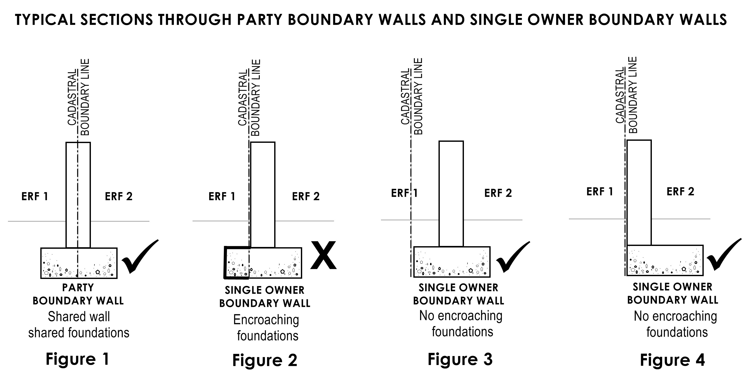
- Retaining walls
- A retaining wall (as indicated in Figure 2 below) is a structure designed and constructed to resist the lateral pressure of soil, when there is a desired change in ground elevation that exceeds the angle of repose of the soil.
- Any wall built to support soil that is higher than 300mm on one side of the wall than it is on the other side, and also serves as a boundary wall is considered a retaining, and must be constructed accordingly.
- All retaining walls require plans that are approved, and they must be designed by a competent person and built it in accordance with SANS 10400 and this Bylaw.
- Any persons who tampers with the natural slope of the ground is responsible for retaining the ground.
- any ground that has been tampered with and is not retained must be cut at an angle of 45 degrees and grassed to prevent soil erosion.
- Retaining wall weep-holes must not be below ground level.
- Any person who plugs a weep-hole to prevent natural seepage shall be guilty of an offence.

Figure 2: TYPICAL SECTION THROUGH A RETAINING WALL
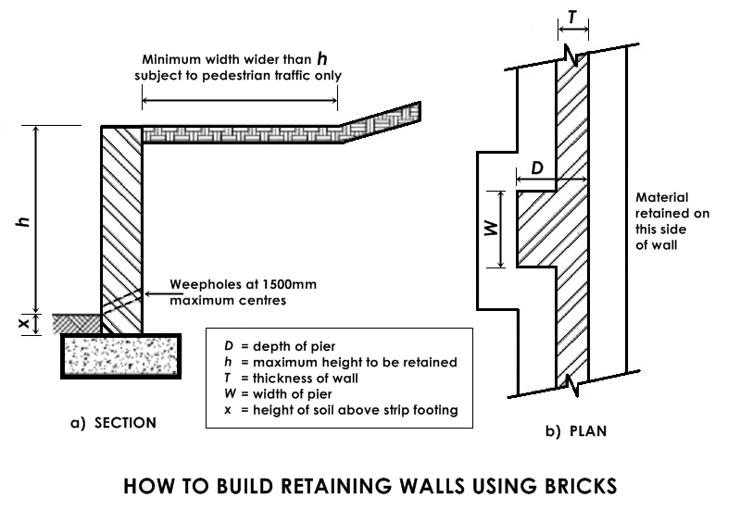

- Exposure of boundary pegs
- Boundary pegs must be exposed prior to the commencement of any construction work on site at the time of building plan submission. If pegs have been removed or cannot be found a professional registered land surveyor must be appointed by the owner to expose and position new pegs.
- Expose the metal peg and use wood or plastic indicators to flag the positon of the peg.

- Maintenance
- Each property owner is responsible for maintaining his/ her side of the fence or party boundary wall regardless who built the fence or wall because it benefits both parties.
- Dispute:
- Any party who causes the damage to the boundary wall, whether intentional or unintentional is liable for fixing the damage, however if the damage is caused by natural disaster both parties should share the cost as per whatever the agreement might be.

24. Electric Fences
Electric fences shall conform to the following specifications:
24.1. It must be at least 1, 8 m above the level of natural ground at any point and cannot be more than 450mm.
24.2. It may only be erected on top of walls and fences, or attached to them.
24.3. Barbwire or razor fence cannot be electrified by energy.
24.4. It may not encroach over site boundaries.
24.5. The fencing along public road and pathway must have clear warning signs at least 100mm X 200mm in size with a background colour of yellow and all writing in black. The size of the writing must be at least 25mm and the signs need to be identical on both sides. There must be a warning sign at each gate, at each access point and along the fence with a spacing of not more than 10 metres between signs.
24.6. All fencing should be accompanied by either an electric fence system certificate of compliance (EFC) or a certificate of compliance (COC) from a competent person.

CHAPTER 6
TRADITIONAL SETTLEMENT AREAS:
Procedures relating to the management and control of structures erected within Traditional Settlement Areas

25. Building Plan Requirements
Procedures relating to the management and control of structures erected within Traditional Settlement Areas. To ensure that the constitutional rights to a safe living environment, of all residents in the City of uMhlathuze municipal jurisdiction, is being upheld and that building plans and relevant inspections are submitted and completed for all structures.

25.1. Submission requirements
25.1.1. Submission Documents:
To maintain uniformity, all current applications forms will be used, namely:-
- Application for building design
- Agreement of indemnity
- SANS 10400 Form 1-4

The following information is required on all submissions.
- In lieu of Erf Number: the number allocated by the Traditional leader to the dwelling and/or site on which the structure is constructed and the ward number/ farm number.
- Owner’s details: the name and identity number of the head of the household who is entitled to occupy the land.
- In lieu of proof of ownership: letter from Traditional leader indicating the specifics of the land allocated or lease agreement.
- In lieu of Surveyor General Diagram: the GPS coordinates & locality plan of the property.

25.1.2. Submission Fees:
- No submission fees for free standing residential dwellings 45m² or less.
- All other submissions require 50% submission fees as per the municipal tariff of fees.

25.1.3. Inspections:
- All inspections are to be carried out as per municipal requirements, namely:-
- pre-plan inspection
- foundation inspection
- damp proof course inspection
- drainage Inspection
- open roof inspection
- final Inspection
- Inspections are to be booked timeously (i.e. a minimum of 24 hours before it is required).

26. Site Requirements
26.1. In line with the requirements of the National Water Act 1998, (Act No. 36 of 1998), no building plans will be accepted for structures to be constructed within the 50 year flood-lines, 100 year flood-lines and any wetlands. Construction is prohibited, with the exception of the exclusions outlined in the National Water Act and this Bylaw.
26.2. Construction is prohibited over and under service reticulation (i.e. water, sewer, electrical and storm water and gas lines):
26.2.1. A minimum distance of 2.0m should be maintained from all municipal supplied services.
26.2.2. Gas line servitude distance of 12m (6m away from either side of the centre of the pipeline)
26.2.3. Eskom Power line servitudes are as per the table below:

 | 11kV | 22kV | 33kV | 88kV | 132kV | 275kV | V tower
Building Restrictions  (From Centre line) | 12m | 12m | 16m | 16m | 18m | 22m | 24m (V tower 28)
Servitude (overall) | 24m | 24m | 32m | 32m | 36m | 44m | 48m (V tower 56)

27. Structural Requirements
In accordance with SANS 10400 2010 Part A Section 3.3a and as outlined in the definitions, all “buildings” require building plans before construction.

27.1. A 1m wide concrete apron is required around the building where no guttering and downpipes have been installed.
27.2. Storm water and surface water disposal arrangements between dwellings/structures shall make provision for the drainage of sites that are waterlogged or seasonally waterlogged. (Refer to section 21.6(1) of this Bylaw)
27.3. Where there is a risk that groundwater beneath or around the building could adversely affect the stability and properties of the ground, consideration should be given to sub soil drainage or other protection.

27.4. The following information may be required at the discretion of the BCO if the structure does not fall within Category 1:
27.4.1. Agrément Certificate (where there is no prescribed minimum standards for materials that are used in construction)
27.4.2. Engineers Report /Certificate (for structures that have not been built in accordance with the NBR and/or multi storey structures and be structural stable).

28. Traditional Burial Graves & Historic Graves
In order to preserve and protect traditional graves, they should be clearly demarcated.

29. Septic Tanks
29.1. Construction methods before installation of conservancy tanks/ septic tanks
- Excavations shall be deepened locally, where necessary, to remove soft spots;

- Hard spots, wherever practicable, shall be removed;

- Excessive excavations shall be avoided and be shored by timber/steel to prevent collapse of adjacent soils;

- Excavations shall be kept free of surface water

- Where the bottom of the excavation has dried out excessively due to exposure or it has softened due to rain or ground water, the excavation shall be re-bottomed(levelled) before concreting;

- Backfill soil(sand) shall be maintained before compaction, so that a small quantity squeezed in the hand is firm, but does not show signs of moisture;

- Fill(soil/sand/G5) shall be placed in un-compacted layers that do not exceed 100 mm in respect of hand compaction, and 150 mm in respect of compaction by mechanical means; and each un-compacted layer shall be well compacted at before additional fill (soil/sand/G5) material is added.

29.2. Guideline and specifications to construct and install septic tanks
- A masonry/concrete conservancy tank/septic tanks to be used on a site for the reception of sewage shall have a minimum concrete strength of 20mpa (Mix ratio 2 bags cement, 2 wheelbarrows sand, 2 wheelbarrows stone) and all internal sides be plastered to a smooth finish.

- The use of Crusher sand mix is prohibited in concrete construction for septic tanks
- Prefabricated septic tanks shall have a stamp indicating SABS approved and testing by means of regulation 0400 which shall clearly visible.
- Masonry/concrete/prefabricated conservancy tanks/septic tanks shall be designed and constructed in such a way;
- that it will be impervious (leak free) to liquid;
- that there will be a ready means of access for the clearing of such tank;
- be so designed and sited that it is not likely to become a source of nuisance or a danger to health; or
- the structural integrity of adjacent buildings;
- A conservancy tank or septic tank may not be installed less than 2, 0 m from the property boundary, or another structure. (Refer to 29.7 figure 1 below for guideline drawing)
- Generally tanks should be located near driveways to facilitate cleaning by a vacuum tanker located at the front or closest access to property, to allow for easy cleaning and disposal by waste removal service providers and there should be a ready means of access for the clearing of such tank
- Be vented at the building of toilet, the vents should extend above the eaves level of the building.
- No industrial effluent shall be allowed to flow into a septic tank.
(Refer to 29.7 figures 2 & 3 below for guideline drawing)

29.4. Requirements to prevent leaks and contamination.
- Septic tanks should be tested for water tightness.
- It should be filled with water before use and tested over a period of 24 hours for water tightness.
- No chemical additives are needed to assist the digestion process in a septic tank and normal amounts of domestic bleach, caustic materials, soaps, detergents and drain cleaners do not impede the process.
- Only bio degradable cleaning liquids should be used in cleaning of toilets
- Materials such as sanitary towels, facial tissue, coffee grounds, cooking oil and cigarette butts should not be flushed into the tank because they do not biodegrade and will clog the system.

29.5. French drains
French Drains which is to receive effluent shall:
- Be so constructed and located as not to cause the pollution of any spring, stream, well or other source of water which is used or is likely to be used, for drinking, domestic use or kitchen purposes;
- Be so positioned that the foundations of adjacent buildings are not adversely affected by its discharge;
- Be not less than 3 m from any building or boundary of the site on which it is situated;
- French drains should, where possible, be located downhill of a water source such as a borehole or spring. Where location downhill of such water source is not possible, French drains should be located at least 50 m from the water source/river and streams;
- Pipes discharging into French drains shall be open-jointed or perforated.
- The impermeable covering is required to prevent ingress of rain or surface water.
- An inspection pipe shall be installed in all French drains
- French drains shall not be deeper than 1,8 m. Surfaces shall be protected by means of 30 mm to 100 mm thick layer of fine gravel or coarse sand.
- A topsoil layer of between 100 mm and 150 mm shall be placed on top of the drain over an impermeable covering. (Refer to 29.7 Figure 4)
(Refer to 29.7, Figure 5 for cross section detail on French drains)

29.6. Prohibited Installation
No conservancy tank/septic tanks may be constructed where:
- the ground that has a percolation rate (absorption of water in soils) that exceeds 30 min;
- effluent might flow out due to the contours or the strata forming of the ground;
- the site to be affected by such effluent is of insufficient size to accommodate the soaking away of the effluent; and have a minimum depth of 1.5 meters; or
- the level of the water table is, or might be, such as to prevent adequate percolation;
- It is closer than 3m of Municipal water service line for clean water drinking purposes;
- It is closer than 3m of Municipal Storm water network drains and pipes.

29.7. Drawing guide of conversancy/septic tanks
Figure 1: Concrete Septic tank with soak-pit.
2m distance from house to Conservancy tank Soak-away 1.5m away from conservancy tank
Refer to section 29.3 (4) & section 29.6 (v) & (vi) for permissible positioning & minimum depth of 1.5 meters

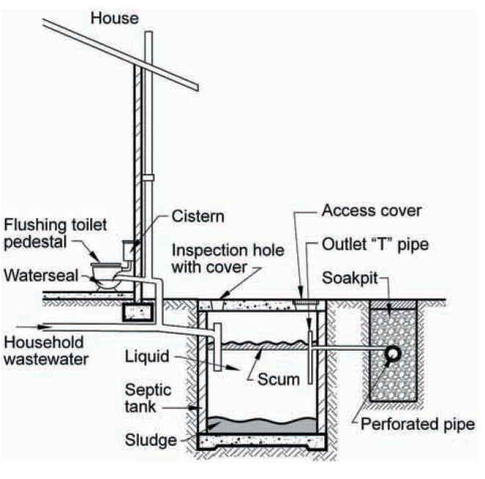

The function of the septic tank is to condition raw sewage, which has a clogging effect on soil, thereby reducing the effective absorption capacity of the subsoil. When the raw sewage enters the tank some of the suspended solids settle to the bottom of the tank and some collect at the surface, with the result that three distinct layers are formed in the tank: a layer of sludge at the bottom, a floating layer of scum on the top and a relatively clear liquid layer in between. The organic solids and dissolved material in the sewage are attacked by bacteria so that the volume of scum and sludge is reduced by liquefaction and gasification. The only function of the final disposal system is to get rid of the effluent (raw sewage) from the septic tank in a safe and inoffensive way.

Figure 2: VIP Toilets (Ventilated vault toilet)
Refer to section 29.3(4) and 29.6(vi) for permissible positioning

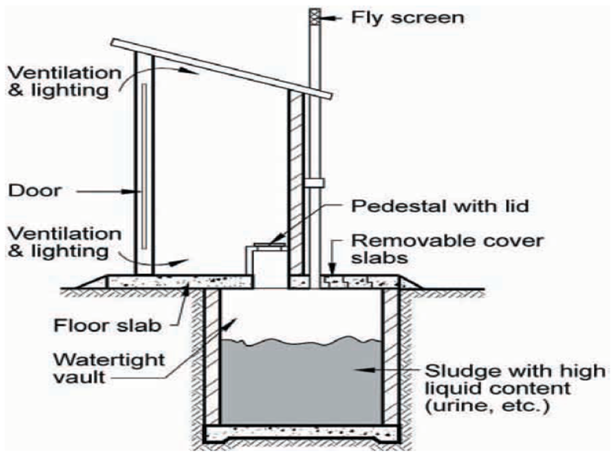

Figure 3: Aqua-privy Toilet
Refer to section 29.3(d) & 29.6(vi) for permissible positioning
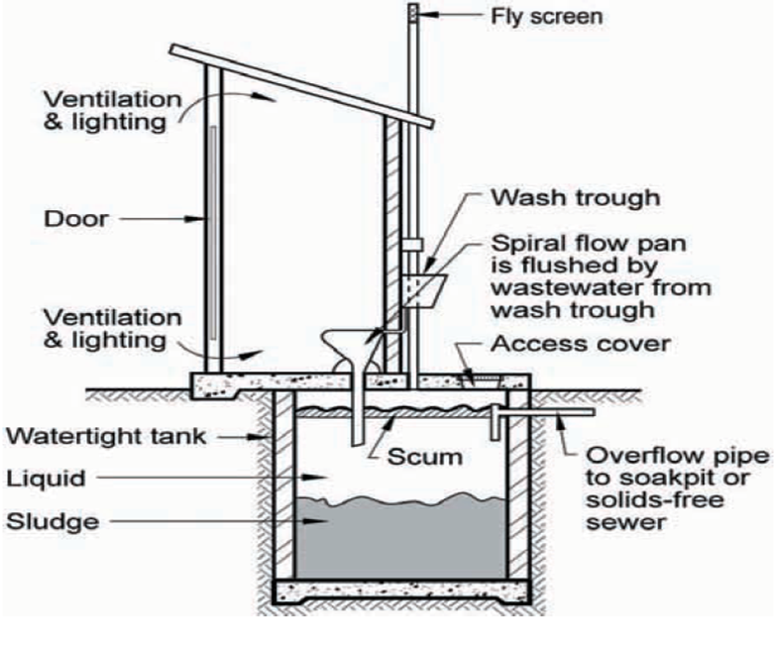

Figure 4
Inspection eye for Septic Tanks and Conversancy tanks

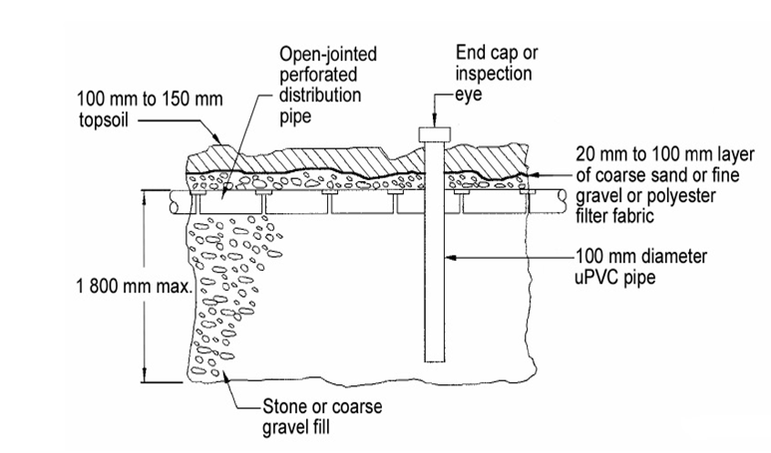

Figure 5
French Drain refer to section 29.5

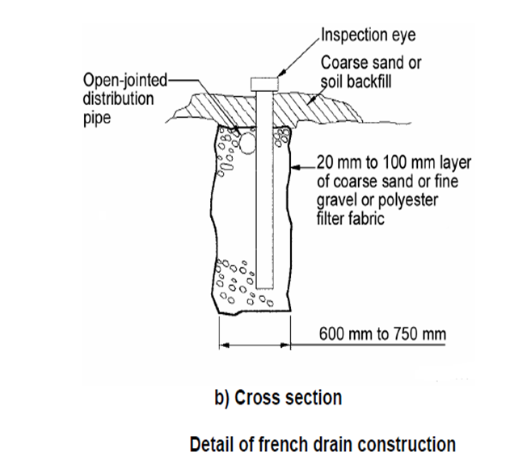

30. Public safety
30.1. Construction site
Construction site must be fenced during the erection of any structure; the fence shall be installed in such a way to prevent any person or child from falling in excavated trenches, open holes and get injured by the building material and tools lying on site.

30.2. Change in height
The protection of the edge of any balcony, bridge, stairway, flat roofs shall be designed to prevent any person from such balcony, stairway, bridge, and flat roof.

30.3. Swimming pool
The owner of any site which contains a swimming pool, fish pond or any other body of water with a depth exceeding 300mm shall ensure that access to such swimming pool is controlled as stipulated in Part D4.4 of the NBR.
CHAPTER 7
ENFORCEMENT

Part 1: Appointment, Functions and Powers of the Municipal Building Control Enforcement Officer

31. Appointment of the Municipal Building Control Enforcement Officer
31.1. Is an employee of the City of uMhlathuze having certification of a competency for law enforcement, and appointed by the Provincial Commissioner of the South African Police service as a peace officer under Section 334(2(a)and
Act No. 68 of 1995, and endorsed by the ‘Accounting Officer’ the Municipal Manager.

32. Powers and Functions of a Municipal Building Control Enforcement Officer
32.1. The powers conferred upon a Peace Officer in terms of Section 41(1) of the Criminal Procedure Act1977, In terms of ‘Section 334’ to exercise the relevant powers namely:
a) The issue of written notices in terms of Section 341 ‘Spot Fines’ i.t.o CPA
b) The issue of written notices in terms of Section 56 ‘Notice of intention to Prosecute’ i.t.o CPA
c) The execution of Warrant of Arrest in terms of Section 44 and 55(2) ‘Warrant’ i.t.o CPA
d) To enforce the National Building Regulations Act 103 of 1977, SANS 10400
e) To enforce the City of uMhlathuze Building Control Bylaw

Part 2: Offences, penalties, reduction and disconnection of engineering services

33. Offences and penalties
33.1. Any person who contravenes any provision or fails to comply with any notice issued in terms of this Bylaw, commits an offence and may at the sole discretion of the municipality or the enforcement official be fined on the spot to the extent as stipulated in Annexure ‘A’ refers to contravention of the NBR Offences and penalties and Annexure ‘B’ Refers to contravention of the Building Control Bylaw Offences and penalties.

33.2. Any person who contravenes any provision or fails to comply with any notice issued in terms of these Bylaws, commits an offence and shall be liable for criminal prosecution, in addition to the spot fines as contemplated in subsection 35.1, and may upon conviction be liable for a fine of R300 000, 00 or imprisonment for a period not exceeding three years or both such fine and imprisonment.

34. Additional penalties
If the contravener fails to Comply with Part 2 and continues activities, Building Control Enforcement Officer may-
a) make recommendation to the Municipal Accounts services to disconnect/reduce engineering services;
b) Impose spot fines tabled in annexure ‘A’ and ‘B’ to the Municipal Rates Account billing.

35. Contravention penalty charge to prevent the continuation of an activity that constitutes an offence
35.1. The Building Control Enforcement Officer may;
a) approach the courts to acquire an interdict to cease such activities/contraventions;
b) approach the courts to issue a Warrant of Arrest;
c) recommend that the Municipal Accounts services disconnect engineering services;
d) recommend that the Municipal Accounts services to be reconnected at contraveners cost.

Part 3: Prosecution

36. Entry by building control enforcement officer
36.1. Any building control enforcement officer may enter any building at any reasonable time with a view to-
- inspect, monitor, investigate or determine whether the building complies with any provision of this Bylaw;
- take photos of the building, whether of the outside of the building or any internal aspect of the building, including any residence;
- serve the owner/ legal representative of the building with a contravention notice contemplated in this Bylaw or any other legislation;
36.2. No person shall hinder or obstruct any building control enforcement officer in the exercise of his or her powers in terms of the Bylaw.
36.3. Any building control officer shall, when entering the premises, produce a valid identification document issued to him or her by the municipality to the owner of such building.
36.4. In the view that requires an immediate action, the BCO may enter any property or building at any given time.

37. Observance of confidentiality pertaining to entry for enforcement purposes
37.1. Notice, order or document required or authorised to be served upon or given to any person under these By-laws may be served or given by delivering the same or a true copy thereof to some person on the premises belonging to or occupied by the person upon whom such service is to be made, or, if there is no person to be found upon such premises who can be so served, by affixing such notice, order or document in a conspicuous part of the premises.

37.2. Any such notice, order or document may also be served by post by a prepaid letter, and if so served by post shall be deemed to have been served at the time when the letter containing the same would be delivered in the ordinary course of post, and, in proving such service, it shall be sufficient to prove that such notice, order or document was properly addressed and put into the post. Any such notice, order or document may be addressed by the description of the ‘owner’ or ‘occupier’ of the premises (naming such premises) in respect of which such notice, order or document is served, without further name or description.

37.3. A person commits an offence if he or she– 18 years or older-
a) obstructs, hinders, or in any manner interferes with the enforcement official who is acting or entitled to act in terms of this By-law
b) fails to obey any lawful instruction or direction given to him or her in terms of this Bylaw
c) a person is guilty of a continuing offence if he or she continues with an offence after notice has been served on him or her in terms of this By-law requiring him or her to cease committing such offence.

38. Relationship between remedies provided in this By-law and other statutory and common law remedies
40.1. Land activities which constitute unlawfulness, the building control enforcement officer may;
(a) Install and display a safety notice on the site for public protection.
(b) Instruct/Issue Notice to contravener to barricade property.
(c) To rectify/cease unlawful land activities.

CHAPTER 8
APPEALS

39. Appeals
39.1. The Appeal Authority Registrar
- The Municipality shall designate an official as the Appeal Authority Registrar and Deputy Registrar respectively.
- In the event that the Municipality has not designated the registrar, the Municipal Manager shall perform the functions of the registrar.

39.1.1. Powers of the Appeal Authority Registrar
- the Appeal Authority Registrar Shall provide administrative support relating to appeals as set out in this By-law, and provide administrative support to the Appeal Authority;
- may direct that an appeal be evaluated by an official of the Municipality or independent person who has relevant skills, knowledge, expertise or qualifications, to evaluate the appeal, and to determine the terms of reference for such official or person;
- may rule that an appeal is invalid if it is not lodged within the time period of 21 days.

39.2. The Appeal Authority
- The Executive Authority of the Municipality shall be an appeal authority to decide all appeals lodged in terms of this By-law.
- The Chairperson of the Executive Authority of the Municipality shall be the Presiding Officer relating to appeal proceedings, provided that he/she may delegate such authority to a member of the Executive Authority.

39.2.1. Powers of the appeal authority
The appeal authority may:
- dismiss an appeal and confirm the decision appealed against;
- uphold part of the appeal and-
- vary the decision appealed against;
- set aside the decision and make a new decision.
- Consider application by any person who has interest in the appeal to intervene as a party;
- Condone any failure by any party to an appeal to comply with its directions or time-limits provided in this By-law;
- Consider application to confirm invalidity of an appeal;
- Subpoena any person to come before it to testify or produce any document;
- Conduct any necessary site inspections or investigations;
- Decide any question concerning its own jurisdiction;
- Give directions relevant to its functions to any person in the service of the provincial administration, a provincial public entity, provincial government business entity or a Municipality relevant to matters referred to in this By-law;
- Postpone an appeal for a reasonable period to obtain further information or advice.

39.3. The Appeal Procedure
- Any person whose rights are affected by a decision taken by the municipality in terms of this Bylaw or any other legislation may appeal against that decision in terms of the Appeals provision contemplated in the Local Government: Municipal Systems Act (Act No. 32 of 2000) by giving a written notice of the appeal and reasons to the Municipal Manager within 21 days of the date of the notification of the decision.

- The appellant must serve the written appeal on the Municipal Manager, the Appeal Authority Registrar and any party to an appeal.

- The Municipal Manager or Appeal Authority Registrar may rule that an appeal is invalid if it is not lodged within the time period contemplated in subsection 39.3(a).

- The Appeal Authority Registrar must acknowledge receipt of an appeal in writing within 7 days.

- An applicant or a person who has a right of appeal and a person who is entitled to lodge a written opposition to an appeal, may, within the 21 days allowed for the lodging of an appeal or written opposition to an appeal, apply to the Municipal Manager or Appeal Authority Registrar for an extension of the period within which to lodge a written appeal or written opposition to an appeal.

- An application for an extension of the period within which to lodge a written appeal or written opposition to an appeal must be in the form of an affidavit, showing good cause as to why the application should be granted.

39.4. Lodging of an appeal
- A person who was served with the written appeal may, within 21 days from the date of service of the memorandum of appeal, submit a responding memorandum to the Appeal Authority Registrar.
- A person who was served with the appeal may in writing notify the Appeal Authority Registrar that he or she does not oppose the appeal.

39.5. Evaluation and referral of an appeal
- The Appeals Authority Registrar may appoint an official or independent person who has relevant skills, knowledge, expertise or qualifications to evaluate the merits of the appeal in writing.
- The independent person’s evaluation report must include –
- the details of the application for municipal building control approval and a summary of the procedure followed;
- the memorandum of appeal submitted;
- the responding memorandum in opposition to the appeal submitted, if any;
- the applicant's response to the responding memorandum, if any; and
- confirmation that appeal complies with NBR, this By-law and any relevant procedure, or details of the defect, if it does not.

- The Appeal Authority Registrar must refer the independent person’s evaluation report and the accompanying documents to the Appeal Authority.

39.6. Site Inspection
- The Appeal Authority may enter upon land or a building relevant to an appeal before it, during normal business hours or at any other reasonable hour, to conduct an inspection of the site under consideration during an appeal.
- The Appeal Authority Registrar must notify all parties to the appeal hearing in writing, of the Appeal Authority’s intention to carry out an inspection.
- Any person who enters upon property or enters a building to attend a site inspection by the Appeal Authority, who gains knowledge of another person’s private or business affairs in the process, must treat that information as confidential and may not disclose it to any other person.

39.7. Appeal Hearing
- An appeal hearing may be disposed of by means of :
- an oral hearing; or
- written proceedings
- The appeal proceeding shall be chaired by the Presiding Officer.
- The Appeal Authority shall consider:
- the independent person’s evaluation report and the accompanying documents;
- any oral representation; and
- any other relevant information.

39.8. Record of Decision by the Appeal Authority
- The Appeal Authority, must make a decision on the appeal within 30 days after the last date of the appeal consideration or hearing and provide the reasons thereof.
- The appeal decision must:
- determine whether the appeal falls within the jurisdiction of the municipal Building Control Appeals Authority;
- confirm, vary or revoke the decision, but no such variation or revocation of a decision may detract from any rights which accrued as a result of the decision;
- furnish written reasons for its decision;
- give directions relevant to its functions to the Municipality.

39.9. Notification of outcome of appeal
The Appeal Authority Registrar must notify the parties of the decision of the Appeal Authority within 30 days after the date of making a decision.

39.10. Offences in connection with proceedings before Appeal Authority
- A person is guilty of an offence, if the person –
- without valid reason, and after having been subpoenaed to appear at the proceedings to testify as a witness or to produce a document or other object, fails to produce the required document and/or attend the proceeding on the date, time and place specified in the subpoena;
- after having appeared in response to the subpoena, fails to remain in attendance at the venue of those proceedings, until excused by the chairperson of the appeal hearing concerned;
- as a witness, refuses to take the oath or to affirm his or her testimony;
- refuses to answer any question fully and to the best of his or her knowledge and belief;
- without good reason fails to produce a document or object in response to a subpoena;
- wilfully hinders or obstructs the Appeal Authority in the exercise of its powers;
- disrupts or wilfully interrupts the proceedings;
- insult, disparages or belittles any member of the Appeal Authority;
- prejudices or improperly influences the proceedings; or
- after entering a premises for the purposes of a site visit, subsequently discloses to any other person trade secrets or any privileged information obtained whilst entering upon land or entering a building, except if the disclosure –
(aa) was made for the purposes of deciding the appeal; or
(bb) was ordered by a competent court or is required under any law.

- A person is guilty of an offence –
- when obstructing the Appeal Authority in exercising a power under this By-law by failing, without good reason, to answer, to the best of that person’s ability, a lawful question by the Appeal Authority;
- when obstructing a person who is acting on behalf of the Appeal Authority; or
- when attempting to exercise a power under this By-law on behalf of the Appeal Authority, without the necessary authority.
- A person convicted of an offence in terms of this section is liable on conviction to a fine not exceeding R5 000.

CHAPTER 9
GENERAL PROVISIONS

40. Legal indemnification
40.1. If a claim is made or legal proceedings are instituted against a member of the Building Control or their support staff arising out of any act or omission by the member or support staff in the performance of his or her duties or the exercise of his or her powers in terms of this By-law, the Municipality must, if it is of the opinion that the person acted or omitted to act in good faith and without negligence−
- if a civil claim or civil proceedings is instituted against the person –
- indemnify the person in respect of such claim or proceedings; and
- provide legal representation for the person at the cost of the Municipality or pay taxed party and party costs of legal representation.
- if a criminal prosecution is instituted against the person, provide for legal representation for the person at the cost of the Municipality.

40.2. A member of Building Control or their support staff has no legal indemnification if he or she, with regard to the act or omission, is liable in law and−
(a) intentionally exceeded his or her powers;
(b) made use of alcohol or drugs;
(c) did not act in the course and scope of his or her employment, designation or appointment;
(d) made an admission that was detrimental to the Municipality; or
(e) failed to comply with or ignored standing instructions, of which he or she was aware of or could reasonably have been aware of, which led to the loss, damage or reason for the claim.

40.3. The Municipality may determine by means of a policy or by other means−
- the terms and conditions of such indemnity and legal representation; and
- circumstances in addition to the circumstances contemplated in this section in which indemnity or legal representation may be withdrawn by the Municipality.

41. Calculation of number of days
41.1. If this By-law prescribes a period for performing an action, the number of days must be calculated by excluding the first day, excluding any public holidays, and by including weekends and the last day, unless the last day happens to fall on a Saturday, Sunday or public holiday, in which case the first work day immediately following the Saturday, Sunday or public holiday must be regarded as the last day of the period.
41.2. Days that the Municipal Council is officially in recess must be excluded from the period in which the Municipality must perform an action in terms of this By-law.

42. Short title and commencement
This Bylaw is called the City of uMhlathuze: Building Control Bylaw, 2019 and takes effect on a date of notice in the Provincial Gazette.

ANNEXURE ‘A’
FINE SCHEDULE
OFFENCES AND PENALTIES IN RELATION TO NATIONAL BUILDING REGULATIONS ACT 103 OF 1977 AND SANS 10400 REGULATIONS MADE THEREUNDER UNDER SECTION 34.1 BUILDING CONTROL BYLAW

REGULATION FINE
Table 1
Building without approved plans (including regulation A25(10) |  | 4(1) & (4) | R2500
Continuing in contravention of a notice prohibiting the erection of a building |  | 10(1) & (2) | R1500
Failure to demolish, alter, secure a building or land F3(2) |  | 12(1) to(6) | R5000
Failure to submit engineers completion certificate A2(1)(f) |  | 14(4)(a) | R1000
Submission of false certificate’s |  | 14(3) | R2000
Occupation or use of a building without certification of occupancy |  | 14(4)(a) | R5000
Prohibition on the use of certain methods or materials |  | 19(1) & (2) | R2000
Table 2
Failure to submit engineers drawings and engineers completion certificates |  | A2(1)(F) | R1000
Failure to provide a certified copy of any approved plans and particulars onsite |  | A2(2) | R2000
False or misleading information |  | A2(3)(f) | R1000
Boundary beacons not pointed out |  | A11(1) & (2) | R1000
Installations, maintenance and operations |  | A15(1) to (5) | R1500
Illegal certificate of identity |  | A17(1) to (4) | R1000
Control of plumbing work |  | A18(1) to (5) | R2500
Failure to notify for commencing demolition |  | A22(1) to (4) | R1500
Use of a building for the purpose other than that indicated on the approved plan |  | A25(1) & (2) | R2000
Deviating from approved plan (foundations walls, freestanding and, retaining. |  | A25(5) | R2000
Unauthorized buildings without the prior approval |  | A25(10) | R5000
Failure to comply with the provisions of a notice in terms of regulationA25 |  | A25(11) | R5000
Failure to safeguard any persons from falling from such balcony bridge ,flat roof or similar place |  | D1 | R5000
Failure to safeguard a swimming pool. |  | D4 | R2000
Failure to comply with provisions concerning demolitions condition |  | E1(3) & (4) | R1500
Protection of the pubic site operations |  | F1(1) to (6) | R5000
Failure to secure unstable soil or land. |  | F3(1) to (3) | R3000
Control of dust and noise |  | F6 | R2000
Cutting into, laying open and demolishing certain building work |  | F7(5) | R1500
Table 4
Accumulation of waste material on site |  | F8(1) & (2) | R5000
Failure to construct and locate the builders shed to the satisfaction of the local authority |  | F10(2) & (7) | R1500
Failure to move, reconstruct, repair or improve the condition of the builders shed and unpermitted use thereof within a specified time in such notice |  | F10(4) & (7) | R1500
Failure to remove builders shed from a site on completion or cessation of work or where the shed is no longer necessary for the purpose for which is was erected |  | F10(5) & (7) | R2500
Accommodating security personnel in a builders shed, not complying with council’s requirements and conditions for the safeguarding of public health and the health of such personnel or in such a way that a nuisance or inconvenience is caused to persons in the vicinity of the premises |  | F10(6) & (7) | R2000
Failure to provide adequate approved sanitary facilities for staff in an approved location before erection or demolition of the premises |  | F11(1) & (2) | R2000
Failure, while excavating, to take adequate precautionary measures to ensure the safety and stability of a property or services is maintained |  | G1(1)(3)& (5) | R5000
Building onto Municipal Servitudes and Service |  | G1(3) & (5) | R5000
Table 5
Laying of a sewer installation not within the premises |  | P1 (1) to (5) | R1500
Prohibition on discharge storm water to enter any drainage installation on any site |  | P3 (2)(3)& (5) | R5000
Prohibition on discharge of any water from a swimming pool, fountains or reservoirs onto any public space or neighbouring property |  | P3 (4) & (5) | R5000
Unauthorised drainage work |  | P6 (1) & (2) | R2000
Putting a sewer installation into use without an inspection |  | P7 (1) to (4) | R1500
Failure to provide storm water disposal requirements. |  | R1 & R2 & A25(9)& (11) | R2500
Failure to provide sufficient protection of occupants or users in any building |  | T1(1) (F1) | R5000
Failure to provide sufficient fire extinguishers or fails to ensure that such extinguishers are installed, maintained, and services |  | T2(1) | R5000

ANNEXURE ‘B’
FINE SCHEDULE
OFFENCES AND PENALTIES IN RELATION TO CITY OF UMHLATHUZE BUILDING CONTROL BYLAW;

SECTION FINE
Table 6
Problem Buildings | 18 | R5000
Encroachments of boundary wall into Municipal property/ adjacent property | 22 | R5000
Maintenance of boundary wall/ party Walls | 22.5 | R1000
Structural integrity of building | 18.3 | R2500
Derelict buildings | 18.3 | R5000
Dumping of building rubble | 21.6 | R2000
Illegal temporary structures | 20 | R2000
Inciting/preventing building Control law enforcement officer from entering premises or doing their job | 18.2 | R2500
Illegal carports and awnings | 19.1.3 | R2500
Control of Storm water relay | 21.7 | R3000

Table 7
Subject to Traditional Areas

Failure to submit building plans | 25 | R2500
Building without approved plans | 25.1 | R2500
Building over/onto Municipal property, road reserve, landfills, flood line areas. | 28 | R5000
Structural Integrity of building | 27 | R2500
Endangering the public | 31 | R5000
Encroachment of walls onto neighbouring property | 34 | R5000
Incorrect installation of septic tanks | 30 | R1500

ANNEXURE ‘C’
WRITTEN NOTICE TO APPEAR IN COURT (Section 56 of Criminal Procedure Act 51 of 1977)
A TO
SURNAME
FIRST NAME/S
IDENTITY NO | OCCUPATION |  | NATIONALITY
GENDER | AGE |  | MAGISTERIAL DISTRICT
RESIDENTIAL ADDRESS |  | BUSINESS ADDRESS
B
You are hereby called upon in terms of section 56 of the Criminal Procedure Act, 1977 (Act 51 of 1977) to appear before the Court mentioned below on the trial date mentioned below at 08h30 to answer to the charge of :
COUNT 1

COUNT 2

Alternative

or such other charge as the Public Prosecutor may bring against you on the grounds that upon or about
on (date):

Address / Vicinity

In the said district you did wrongfully and unlawfully

C
DATE AND PLACE YOU ARE PERSONALLY TO APPEAR IN COURT
Date of Trial | Place of Trial | Court No
D
DATE AND PLACE WHERE ADMISSION OF GUILT FINE/S MAY BE PAID TO VOID COURT APPEARANCE. Admission of guilt fine/s of:
Charge 1 | Charge 2 | Alternative Charge
R | R | R
Date | Place: Any police station in the district or municipal office mentioned above
E
Date | Place
The original hereof was today handed to the above mentioned accused personally and the import thereof explained to him/her.

_______________________________________________ _________________________ _________________________________
Peace Officer Time Code No.
F
IMPORTANT INFORMATION TO THE ACCUSED
1. WARNING: If you fail to comply with this notice or fail to remain in attendance at the proceedings, you may be arrested and sentenced to a fine not exceeding R5000 or imprisonment for a period not exceeding 3 months.
2. CONDITIONS OF PAYMENT OF ADMISSION OF GUIT FINE: Should you prefer to pay the admission of guilt fine, this document is to accompany such payment. Only cash, r debit order or bank guaranteed cheque will be accepted. Debit orders, or cheques must be made payable to the relevant authority (see part D above). You need not appear in court.
3. Payment can be made 3 days before the said date of payment.
4. If it is your intention to defend the case against you, you are requested to inform the Prosecutor of your intentions in writing on or before the above-mentioned date of payment of the fine. Failure to do so may delay the case or may even result in a postponement of the case.
5. In terms of section 73(2A) Act 51/1977 you are hereby informed of your right to be represented at your own expense by a legal representative of your own choice. If you cannot afford legal representation, you may apply for legal aid to your local Legal Aid board.
6. The mere fact that a representation has been made does not suspend the summons. Its requirements must still be complied with.

ANNEXURE ‘D’

CITY OF uMHLATHUZE BUILDING CONTROL
NOTICE OF CONTRAVENTION
Mr/Mrs/Miss:…………………………………………………………………………………………………………………………….
ADDRESS:………………………………………………………………………….ERF No:……………………………………………
TIME THAT NOTICE SERVED:…………………………………………………………………………………………………………..
Notice is hereby given that you contravened-
Section…………………………………………………………of the…………………………………..Bylaw/NBR SANS 10400
In that you (include full description of transgression/s)
………………………………………………………………………………………………………………………………………………..
………………………………………………………………………………………………………………………………………………..
………………………………………………………………………………………………………………………………………………..
………………………………………………………………………………………………………………………………………………..
………………………………………………………………………………………………………………………………………………..
DATE/S ON WHICH TRANSGRESSION WAS COMMITTED…………………………………………………………………………..
In order to avoid legal proceedings being instituted against you, you are requested to rectify the situation by doing the following:………………………………………………………………………………………………………………………
………………………………………………………………………………………………………………………………………………..
………………………………………………………………………………………………………………………………………………..
………………………………………………………………………………………………………………………………………………..
………………………………………………………………………………………………………………………………………………..
The remedial work must be undertaken immediately/within…………….days from the date/time of this notice, failure to comply with this notice constitutes a criminal offence, which may render you liable conviction to a fine or imprisonment.
Failing by which a fine not exceeding R…………………………………………..per day
You may submit written representation to…………………………………………………………………………………………...
within 7days of the serving of this notice.

BUILDING CONTROL OFFICIAL…………………………SIGN…………………………DATE………………..TEL ………………….

RECIPIENT……………………………………………………SIGN……………………….DATE………………..TEL…………………...

ANNEXURE ‘E’
BUILDING CONTROL PUBLIC COMPLAINTS FORM
A | DETAILS OF COMPLAINANT
NAME & SURNAME
STREET ADDRESS
CONTACT TELEPHONE NO
E-MAIL ADDRESS
B | PARTICULARS OF COMPLAINT
DATE OF COMPLAINT |  |  |  |  | TIME
NATURE OF LODGMENT |  | TELEPHONIC |  | EMAIL |  |  | IN PERSON
NAME OF OFFICIAL WHO RECEIVED COMPLAINT
NATURE OF COMPLAINT
(eg illegal construction/noise etc)
BRIEF DESCRIPTION OF COMPLAINT
DATES AND TIMES OF WHEN TRANSGRESSION OCCURED
ADDRESS WHERE TRANSGRESSION OCCURRED

INVESTIGATION OF COMPLAINT

C | PARTICULARS OF TRANSGRESSOR
NAME & SURNAME
ERF NO
STREET ADDRESS
CONTACT TELEPHONE NO
E-MAIL

D | INVESTIGATION INFORMATION
DATE COMPLAINT RECIEVED
DATE OF SITE INSPECTION
NATURE OF CONTRAVENTION |  | DEV CONTROL |  |  | BUILDING CONTROL |  |  |  |  | OTHER
FINDINGS :

BUILDING INSPECTOR |  |  |  |  |  | Signature
TOWN PLANNER |  |  |  |  |  | Signature
C | RECOMMENDATION
ACTION TAKEN :

WRITTEN WARNING DMS REF NO.
FINE ISSUED. FINE NO
OTHER
Was the complainant satisfied with outcome  Was the complainant satisfied with the handling of the complaint |  |  |  |  |  |  | YES |  |  |  | NO
 |  |  |  |  |  |  | YES |  |  |  | NO
……………………………. …………………………  Signature Date  LAND USE MANAGER |  |  |  | ………………………… ………………………….  Signature Date  BUILDING CONTROL OFFICER

ANNEXURE ‘F’
MINOR BUILDING WORK APPLICATION
i.t.o Regulation A1(5) of NATIONAL BUILDING REGULATIONS ACT No. 103 OF 1977

PROPERTY  DETAILS | Erf No. |  | Suburb
 | Street Address
 | Age of existing building (in years)
 | NOTE: The OWNER is responsible for ensuring compliance with the National Heritage Resources Act, 1999, National Environmental Management Act, 1998, Local Government: Municipal Systems Act, 2000, etc. is complied with prior to submitting an application to the Local Authority for consideration. In respect of the National Heritage Resources Act, 1999, ANY & ALL development, but not limited to new structures, the demolition of and / or alterations or additions to structures, on sites that contain existing buildings older than 60 years, require permits to be obtained from Amafa aKwa-Zulu Natali prior to submission of an application to the Local Authority for consideration. Failure to comply may result in unnecessary delays.
PROPOSAL  Description of work | Description of Minor Building Work to be carried out
MBW FLOOR AREA  m² | FLOOR AREA means the total covered plan area of all floors contained within the outer extremities of a building. The floor area for Submission Fee calculation is determined as follows: The floor area is taken as the total plan area of every floor measured from the external face of the external walls ( and the face of retaining wall in contact with the ground ) ie: overall dimensions of building are used for calculation of floor area, NOT internal room dimensions.
PROPERTY  OWNER’S DETAILS Non-compliance with the Submission Checklist will result in the Application being refused creating un-necessary delays for the Owner / Applicant. | Owners Name
 | Physical Address
 | Postal Address
 | Cell Number |  |  | Email
DECLARATION BY OWNER

I/We declare that I/we have personally checked the Title Deeds or any other document for the property concerned and that the proposed work is not contrary to any restrictive conditions or servitudes applicable thereto. I/We further declare that the boundary beacon pegs conform with positions as per the applicable Approved SG Diagram. I/We further declare that the application does not conflict with any other applicable laws, eg.: National Heritage Resources Act, 1999, National Environmental Management Act, 1998, Local Government: Municipal Systems Act, 2000, etc., and that ALL information as provided is true and correct. In the event of any contraventions, I/we will bear the sole responsibility to rectify the aforesaid contraventions.

Owner’s Signature: _______________________________________ Date: ______________________

NOTE: The Owner / Applicant is responsible for tracking the status of the application once submitted to the Council. The Local Authority cannot guarantee that posted notifications will be received as this is the domain of the SA Post Office.

FOR OFFICIAL USE: This application is accompanied by the following documentation:

Proof of ownership
A minimum size A4 Site Layout and Sketch of Proposal.
Site Layout is to indicate position and overall dimensions of existing buildings and proposed MBW and dimensions of the MBW proposal from buildings and boundaries. Sketch to consist of a minimum of a plan, two elevations and section to indicate, size and height of proposal, method of construction and material from which constructed. This sketch does not have to be compiled by a competent registered professional.
Proof of payment
The above application has been approved in accordance with the City of uMhlathuze’s Building Control Bylaw, section*
APPROVED DATE |  | BUILDING CONTROL OFFICER (Signature)

ANNEXURE ‘G’
APPLICATION FOR ERECTION OF A TEMPORARY STRUCTURE
i.t.o Section A23 of the National Building Regulations Act 103 of 1977

PROPERTY  DETAILS | Erf No. | Suburb
 | Street Address
 | Existing use of site |  | Current Zoning
PROPERTY  OWNER’S DETAILS Non-compliance with the Submission Checklist will result in the Application being refused creating un-necessary delays for the Owner / Applicant. | Owners Name
 | Physical Address
 | Postal Address
 | Cell Number |  | Email
PROPOSAL  Description of work | Proposed Temporary structure
 | Intended use of the structure
 | Area (size) of structure
DECLARATION BY OWNER

I/We, the undersigned, declare that I/we have personally checked the Title Deeds or any other document for the property concerned and that the proposed work is not contrary to any restrictive conditions or servitudes applicable thereto. I/We further declare that the boundary beacon pegs conform to positions as per the applicable Approved SG Diagram. ALL information as provided is true and correct at time of submission. In the event of any contraventions, I/we will bear the sole responsibility to rectify the aforesaid contraventions.

I/We, the undersigned, undertake to demolish or remove the temporary structure within 14 days of the expiry of the approval granted.

Owner’s Signature: _______________________________________ Date: ______________________

NOTE: The Owner / Applicant is responsible for tracking the status of the application once submitted to the Council. The Local Authority cannot guarantee that posted notifications will be received as this is the domain of the SA Post Office.

FOR OFFICIAL USE: This application is accompanied by the following documentation:
Proof of ownership
Plans depicting the Floor layout, Site plan, elevations and section
Proof of payment
The above application has been approved, and is valid for a period of 6 MONTHS in accordance with the City of uMhlathuze’s Building Control Bylaw, section*
APPROVED DATE | BUILDING CONTROL OFFICER (Signature)
ANNEXURE ‘H’

APPLICATION PERMISSION TO DEMOLISH IN TERMS OF PART E OF THE NBR AND BUILDING STANDARDS ACT,103 OF 1977, AS AMENDED & SECTION 21.4 OF BUILDING CONTROL BYLAW

A. | LOCATION |  |  |  |  |  |  |  |  |  |  |  |  |  |  | Private Property |  |  |  |  |  |  |  |  |  |  |  |  |  |  |  |  |  |  |  |  |  |  |  |  |  |  |  |  |  |  |  |  |  | Public Property (Council land)
 |  |  |  |  |  |  |  |  |  |  |  |  |  |  |  |  | Township
 | Erf Number  (as per SG Diagram) |  |  |  |  |  |  |  |  |  |  |  |  | RICHARDS BAY |  |  |  |  |  |  |  |  |  |  |  |  |  |  |  |  |  |  |  | ESIKHALENI |  |  |  |  |  |  |  |  |  |  |  |  |  |  |  |  |  |  |  |  |  |  |  |  | NSELENI
 |  |  |  |  |  |  |  |  |  |  |  |  |  | MZINGAZI |  |  |  |  |  |  |  |  |  |  |  |  |  |  |  |  |  |  |  | MANDLAZINI |  |  |  |  |  |  |  |  |  |  |  |  |  |  |  |  |  |  |  |  |  |  |  |  | VULINDLELA
 |  |  |  |  |  |  |  |  |  |  |  |  |  | EMPANGENI |  |  |  |  |  |  |  |  |  |  |  |  |  |  |  |  |  |  |  | NGELEZANE |  |  |  |  |  |  |  |  |  |  |  |  |  |  |  |  |  |  |  |  |  |  |  |  | KULEKA
 |  |  |  |  |  |  |  |  |  |  |  |  |  | EMP RAIL |  |  |  |  |  |  |  |  |  |  |  |  |  |  |  |  |  |  |  | FELIXTON |  |  |  |  |  |  |  |  |  |  |  |  |  |  |  |  |  |  |  |  |  |  |  |  | NTAMBANANA
3. | Street Address:
4. | Suburb/Extension: |  |  |  |  |  |  |  |  |  |  |  |  |  |  |  |  |  |  |  |  |  |  |  |  |  |  |  |  |  |  |  |  |  |  |  |  |  |  |  |  | 5. |  |  |  |  | Erf Size:
B. | DESCRIPTION
 |  |  |  |  |  |  |  |  |  |  |  |  |  |  |  |  |  |  |  |  |  |  |  |  |  |  |  |  |  |  |  |  |  |  |  |  |  |  |  |  |  |  |  |  |  |  |  |  |  |  |  |  |  |  |  |  |  |  |  |  |  |  |  |  |  |  |  |  |  |  |  |  |  |  |  | Pool
1. | Property Use |  |  |  |  |  | Main Building |  |  |  |  |  |  |  |  |  |  |  | Outbuilding |  |  |  |  |  |  |  |  |  |  | Verandah or lapa |  |  |  |  |  |  |  |  |  |  | Pool |  |  |  |  |  |  |  |  | Walls |  |  |  |  |  |  | Others
 | Floor area to be demolished : |  |  |  |  |  | ________ |  |  |  |  |  |  |  |  |  |  |  | m² |  |  |  |  |  |  |  |  |  |  |  |  |  |  |  |  |  |  |  |  |  |  |  |  |  |  |  |  |  |  |  |  |  |  |  |  |  | ---------------------------------------------------------------------------
2. | Exterior Finish |  |  |  |  |  |  |  |  |  |  | Face Brick |  |  |  |  |  |  |  |  |  |  |  |  |  |  | Plaster |  |  |  |  |  |  |  |  |  |  | Other
3. | Roof Surface |  |  |  |  |  |  |  |  |  |  | Tiles |  |  |  |  |  |  |  |  |  |  |  |  |  |  | Thatch |  |  |  |  |  |  |  |  |  |  | Other
4. Age of building (Buildings over 60 years old require written permission from Amafa Kwazulu-Natal):
5. Reason for demolition :

 |  |  |  |  |  | NOTE: To be arranged with the Department of the City Electrical Engineer
6. | Electricity Termination |  |  |  |  |  |  |  |  |  |  |  | Single Phase |  |  |  |  |  |  |  |  |  |  |  |  | Three Phase |  |  |  |  |  |  |  |  |  |  |  |  | Other
 |  |  |  |  |  |  |  |  |  |  |  |  |  |  |  |  |  |  |  |  |  |  |  |  |  |  |  |  |  |  |  |  |  |  |  |  |  |  | ----------------------------------------------------------------------------------------------------------------------------------------------------------------------------------
7. | Water Connection  Termination |  |  |  | Industrial Water  connection (mm) ø |  |  |  |  |  |  |  |  |  |  |  |  |  |  |  |  |  |  |  |  |  |  |  |  |  |  | Domestic Water connection (mm) ø |  |  |  |  |  |  |  |  |  |  |  |  |  |  |  |  |  |  |  |  | Fire  connection (mm) ø
C. | PARTICULARS
1. | Owner : |  |  |  |  |  |  |  |  |  |  |  |  |  |  |  |  |  |  |  |  |  |  |  |  |  |  |  |  |  |  |  |  |  |  |  |  |  |  |  |  |  |  |  |  |  |  |  |  |  | Tel No :
 | Email: Cell No :
2. | Person / Company responsible for demolition : |  |  |  |  |  |  |  |  |  |  |  |  |  |  |  |  |  |  |  |  |  |  |  |  |  |  |  |  |  |  |  |  |  |  |  |  |  |  |  |  |  |  |  |  |  |  |  |  |  | Tel No :
 | Email: Cell No :
3. | Professional Engineer Appointed : |  |  |  |  |  |  |  |  |  |  |  |  |  |  |  |  |  |  |  |  |  |  |  |  |  |  |  |  |  |  |  |  |  |  |  |  |  |  |  |  |  |  |  |  |  |  |  |  |  | Tel No :
 | Email: Cell No :
E. | PLANS

A copy of a site plan clearly demarcating the structure to be demolished to be submitted with this application

A  C  C  E  P  T  A  N  C  E  OF  O  B  L  I  G  A  T  I  O  N  S  A  N  D  R  E  G  U  L  A  T  I  O  N  S | I, …………………………………………………………………………………………………………………………………  (in the capacity of) …………………………………………………………………………………………  of (Erf Description) ………………………………………………………………………………………………, accept herewith full responsibility for all obligations imposed by Part E of the National building Regulations and building Standards Act , 103 of 1977, including the obligations set out below:
 | THESE OBLIGATIONS SHALL INCLUDE THE FOLLOWING
 | ❶ | Provision for the protection of the public during demolition;
 | ❷❸  ❹ | Provision of detailed structural engineering survey of the structure carried out by a competent person  Removal of all excess building rubble from the site and all adjoining stands during and after completion of the demolition phase;  Control of dust and noise
 | DATE |  |  | SIGNATURE
 | OFFICIAL USE ONLY

Information forwarded to the Municipal Valuers :
IMAFA Implications:

Electricity terminated

Water connection terminated:

 | APPROVED DATE |  |  | FOR: BUILDING CONTROL OFFICER

